**Lab 4**

**1. Create a page named login.php. If user provides correct username and password and does not select remember me option then set cookie for 1 minute and if selects remember me option then set cookie for 2 minutes. During this time frame if user again provides correct username and password then displays message “You are already logged in...” and if incorrect username and/ or password then displays message “Username/Password Invalid”**

**Code:**

<h1>User login</h1><br>

<form action="" method="POST">

Username: <input type="text" name="username" value=""><br>

Password: <input type="Password" name="password" value=""><br>

Remember me: <input type="checkbox" name="check"><br>

<input type="submit" name="login" value="login"><br>

</form>

<?php

if(isset($_POST['login'])){

if(!empty($_POST['username']) && !empty($_POST['password'])){

if(isset($_POST['check'])){

if($_POST['username'] == "juzar" && $_POST['password'] == "juzar")

if(!isset($_COOKIE['username']) && !isset($_COOKIE['password'])){

echo "OK, so now cookie is set for 2 min...";

setcookie('username',$_POST['username'],60*2+time());

setcookie('password',$_POST['password'],60*2+time());

}else{

echo "You are already logged in..... ";

}

else

echo "Username/Password Invalid";

}else{

if($_POST['username'] == "juzar" && $_POST['password'] == "juzar")

if(!isset($_COOKIE['username']) && !isset($_COOKIE['password'])){

echo "OK, so now cookie is set for 2 min...";

setcookie('username',$_POST['username'],60*2+time());

setcookie('password',$_POST['password'],60*2+time());

}else{

echo "You are already logged in..... ";

}

else

echo "Username/Password Invalid";

}

}else {

//if(empty($_POST['username']) || empty($_POST['password']))

echo "You must supply a username and password";

}

}

// if (!isset($_COOKIE['username']) !isset($_COOKIE['password'])) {

// }

?>

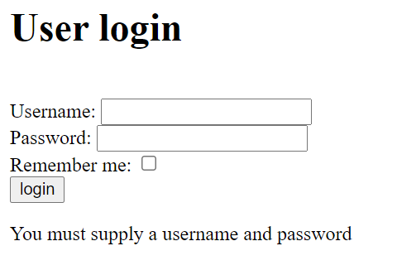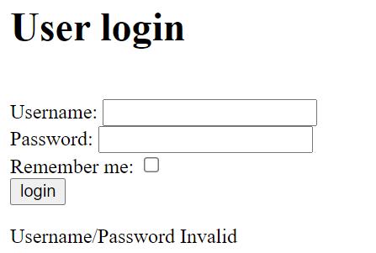**Output:**

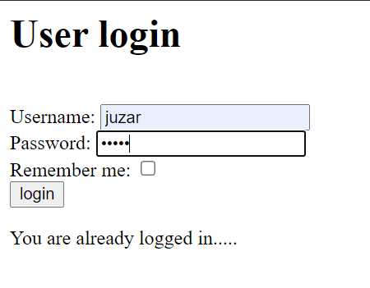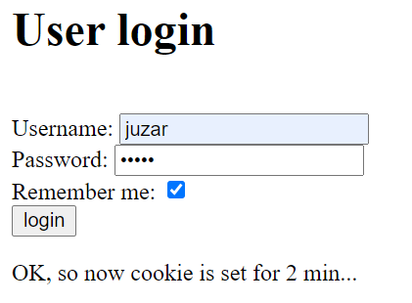

**2. Create a page ‘index.php’ that asks for username and password of user. If incorrect credentials are provided then it display message “Incorrect Username/Password” on ‘home.php’ page and if credentials are correct then user is redirected to home page ‘home.php’ and it has content as given in Fig.3. When user clicks on Signout hyperlink user is redirected to ‘logout.php’ page and gets display as in Fig. 4.**

**Code:**

**Index.php:**

<form action="home.php" method="POST">

<table border="1">

<tr>

<td>Username:</td>

<td><input type="text" name="username"></td>

</tr>

<tr>

<td>Password:</td>

<td><input type="Password" name="password"></td>

</tr>

<tr>

<td><input type="submit" name="submit" value="Submit Query"></td>

<td><input type="Reset" name=""></td>

</tr>

<tr>

<td colspan="2"><a href="">Newuser</a></td>

</tr>

</table>

</form>

**Home.php:**

<?php

session_start();

if(isset($_POST['submit'])){

if(isset($_POST['username']) && isset($_POST['password'])){

if($_POST['username'] == "juzar" && $_POST['password'] == "antri"){

$_SESSION['name'] = $_POST['username'];

echo "<table border='1'> ";

echo "<tr>";

echo "<td><h1>Home Page</h1></td>";

echo "<td><a href='logout.php'>Signout</a></td>";

echo "</tr>";

echo "<tr>";

echo "</tr>";

echo "<td colspan='2'>Welcome " . $_POST['username'] . "</td>";

echo "</table>";

}else{

echo "Incorrect Username/Password";

}

}

}

?>

**Logout.php:**

<?php

session_start();

echo "Your are signed out Click <a href='index.php'>Here</a> to login again" ;

unset($_SESSION['name']);

?>

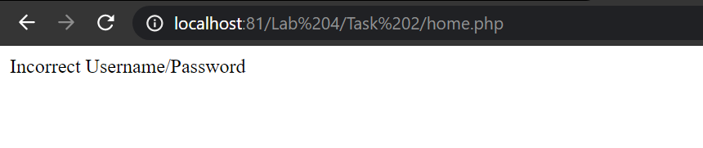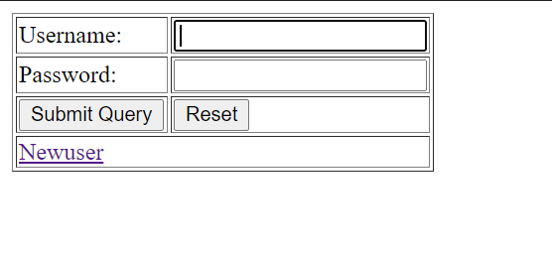**Output:**

